Document of Text Recognition (Design Phase)

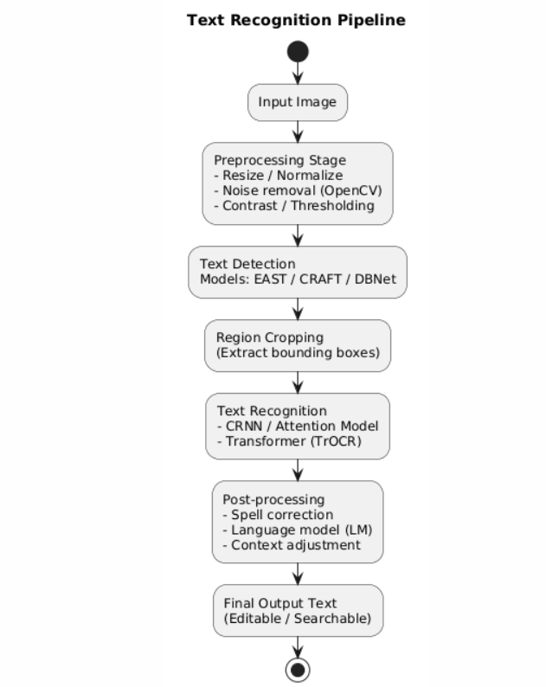

Flow of Work:

1. **Beginner:**
   * Extract text from street sign images using Tesseract + OpenCV.
2. **Intermediate:**
   * Build a CRNN model to read license plates.
   * Dataset: [CCPD (Chinese City Parking Dataset)] or synthetic plates.
3. **Advanced:**
   * Build a Google Lens clone: detect + recognize text in natural scenes.
   * Add **translation** using a pre-trained NMT model (like MarianMT).
4. **Cutting Edge:**
   * Try **TrOCR (Transformer OCR)** or **Donut (Document Understanding Transformer)**.
   * Use on scanned documents, receipts, or handwritten notes.

The Process consists of two sub parts which are **text detection** and **text recognition** mainly.